**Outliers**

In linear regression, an outlier is an observation with large residual.

We use standardized residuals as a means for identifying outliers. Use histogram of standardized residuals.

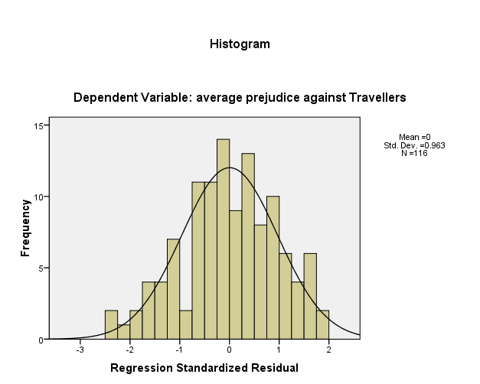

This histogram indicates a couple of extreme residuals that would be interesting to investigate further. We consider the bars outside the -2 to 2 interval, and we consider bars that are substantially different to what the bell curve line suggests it should be.

The height of the first bar of the histogram is much larger than the trendline. ( Cases 59 and 65) . The second bar is also outside the -2,2 interval, but the number of cases (1, case 5) in this bar is consistent with what the bell curve line suggests it should be.

***Talk about these three case??? First two are most important , but other one (case 5) could be mentioned too.***

List of top 10 extreme values of standardized residuals.

| **Outlier Statisticsa** | | | |
| --- | --- | --- | --- |
|  |  | Case Number | Statistic |
| Std. Residual | 1 | 59 | -2.423 |
| 2 | 65 | -2.398 |
| 3 | 5 | -2.243 |
| 4 | 115 | -1.998 |
| 5 | 60 | 1.924 |
| 6 | 19 | 1.817 |
| 7 | 1 | -1.767 |
| 8 | 109 | 1.731 |
| 9 | 17 | 1.719 |
| 10 | 10 | 1.670 |
| a. Dependent Variable: average prejudice against Travellers | | | |

**Normality of Residuals**

One of the assumptions of linear regression analysis is that the residuals are normally distributed.

Does the standardized residuals follows the bell curve line ? (as previous) **YES**

Does the points on the PP plot follow the trendline ? **YES**

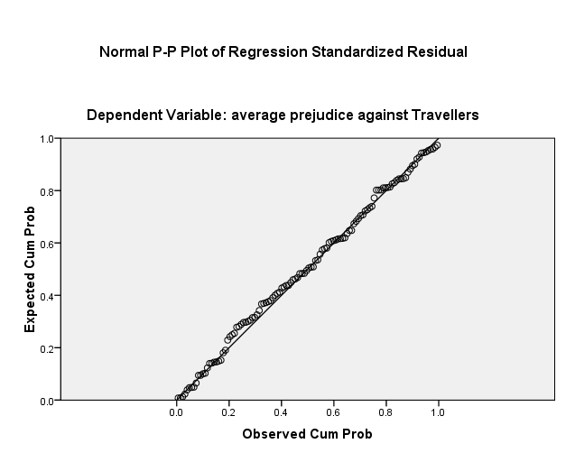

**Homoskedascity**

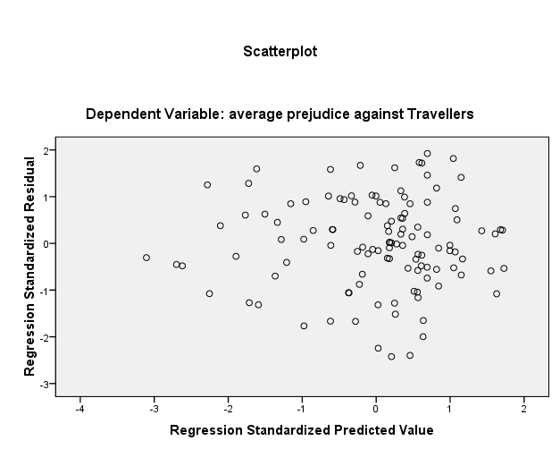

Homoskedascity : Constant variance: If a model is well fitted, there should be no pattern in this plot.

In the above plot one can assume constant variance if there are no trend visible in the above plot.

An counter example of a trend ( known as the funnel effect) is something like this

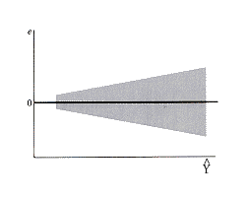

If a plot looks like this - then the assumption of constant variance is wrong. The variance increases as the predicted values increase. This model is not well fitted.